**S-129PT4-x.x**

## Paper for Consideration by S-129PT

## Feedback on UKCM test dataset dated 22nd Mar 2018

|  |  |
| --- | --- |
| ***Submitted by:*** | Hannu Peiponen / Furuno Finland |
| ***Date:*** | 22nd Jun 2018 |
| ***Executive Summary:*** | This paper is about experience gained implementing early prototype of S-129 compliant ECDIS by Furuno Finland  This paper focus on the test dataset provided by OMC on 22nd Mar 2018 |
| ***Related Documents:*** |  |
| ***Related Projects:*** | Creation of S-129 Product Specification |

## Introduction / Background

Chris Hens/OMC and Hannu Peiponen/Furuno met at the eNav Underway 2018 conference in Denmark. It was agreed. that OMC will create S-129 test dataset and Furuno will try laboratory implementation of it and report results. This paper is feedback from the Furuno trial implementation.

Furuno has no project funding for S-129. All work is done on “public good” basis. Therefore, it took quite a long time before suitable free resource was available in Jun 2018.

**Result of laboratory trial implementation**

Screen sample shows the result. Details of implementation

* Only basic charts were installed in addition to the S129 chart.
* The S129 overlay was generated from **S129_OMC/S129_feature_omc_example.xml**.

**Note** We needed to fix an encoding error in the test dataset to make it usable: one erroneous comma was removed from the contents of the first element

<Dataset>/<UnderKeelClearancePlan>/<S129_ControlPoint>/<UnderKeelClearanceControlPoint>/<geometry>/<S100:Point>/<gml:pos>

S129_feature_omc_example.xml, the first <gml:pos> element uses a comma to separate the two coordinates, which is incorrect. In the same example, the other <gml:pos> elements do no use a comma, which is correct.

See for example “Sample instance” in

<http://www.datypic.com/sc/niem21/e-gml32_pos.html>

* S129_feature_omc_example.xml contains:

1. 2 pieces of <UnderKeelClearanceNonNavigableArea> elements (located in South Korea)

The two red areas visible in the screen sample correspond to the two

<UnderKeelClearanceNonNavigableArea> elements.

1. 0 pieces of <UnderKeelClearanceNavigableArea> elements
2. 2 pieces of <UnderKeelClearanceControlPoint> elements (located in South Korea)

The two black icons visible in the screen sample correspond to the two <UnderKeelClearanceControlPoint> elements.

1. 2 pieces of <UnderKeelClearanceControlPointInformationBox> elements (located in South Korea)
2. 3 pieces of <S40X:waypoint> elements (located in Germany)

* Since no S129 portrayal information was available:

1. both the color and the transparency value of the S129 areas are hard-coded
2. the icon used for representing control points was hard-coded to resemble the one which appears on page 15 of document "Draft Report of the Second Meeting of the S-129 Project Team"

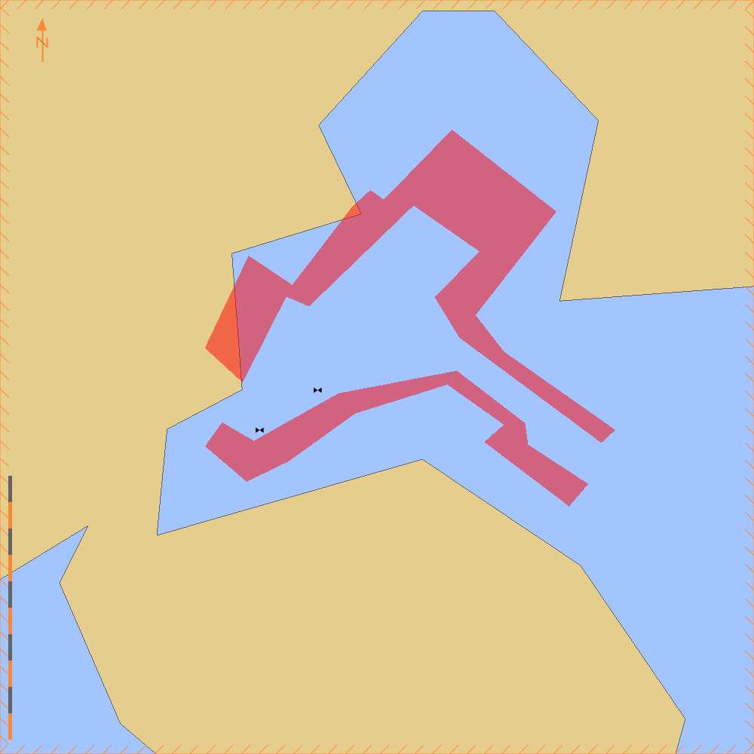

Screen sample from test dataset at scale 1:20 000

**Questions from the implementation team**

The implementation team had some observations which may need to be considered by the S-129PT

1. According to rtz_format_1_1_29032017.xsd, <S40X:leg> should occur no more than once as a child of <S40X:waypoint>. In S129_feature_omc_example.xml, however, one <S40X:waypoint> element has two <S40X:leg> children.
2. In S129_feature_omc_example.xml, two <S40X:leg> elements are empty. As far as we can see this is allowed, but what's the point of such an element?
3. According to S129_ApplicationSchema.xsd, there can be any number of <S129_NavigationArea> elements, and each <S129_NavigationArea> can have any number of <UnderKeelClearanceNavigableArea> and <UnderKeelClearanceNonNavigableArea> children. Is this intentional? Why not exactly one <S129_NavigationArea>?
4. According to S129_ApplicationSchema.xsd, there can be any number of <S129_ControlPoint> elements, and each <S129_ControlPoint> can have any number of <UnderKeelClearanceControlPoint> and <UnderKeelClearanceControlPointInformationBox> children. Is this intentional? Why not exactly one <S129_ControlPoint>?
5. In elements <gml:pos> and <gml:posList> of S129_feature_omc_example.xml, the coordinates are listed in the order (lon, lat), instead of the more conventional (lat, lon). Why?
6. In S129_feature_omc_example.xml, <S129_Route> contains points located in Weser river, near Bremen in Germany. In the same example file, <S129_NavigationArea> and <S129_ControlPoint> refer to places located in South Corea. Such an example is hardly realistic.
7. What's the use of <UnderKeelClearancePlan> (= the only child of <Dataset>)? Why not just <Dataset>?
8. The name of the root element is "Dataset" (lowercase s). In S411, name of the root element is "IceDataSet" (uppercase s).